ATTACHMENT 4 – Indicative Staging Plan

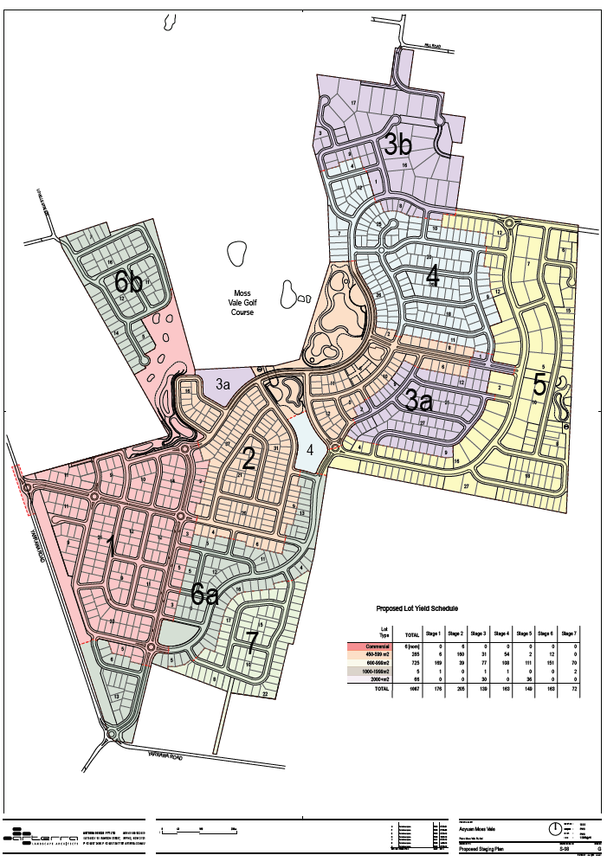
Indicative Staging Plan

